8.55 SHINY DEVELOPERS TALK
DPLYR 1.1.0
reducing friction, taking you out of the mood to write code
case_when had a lot of issues with the values introudced
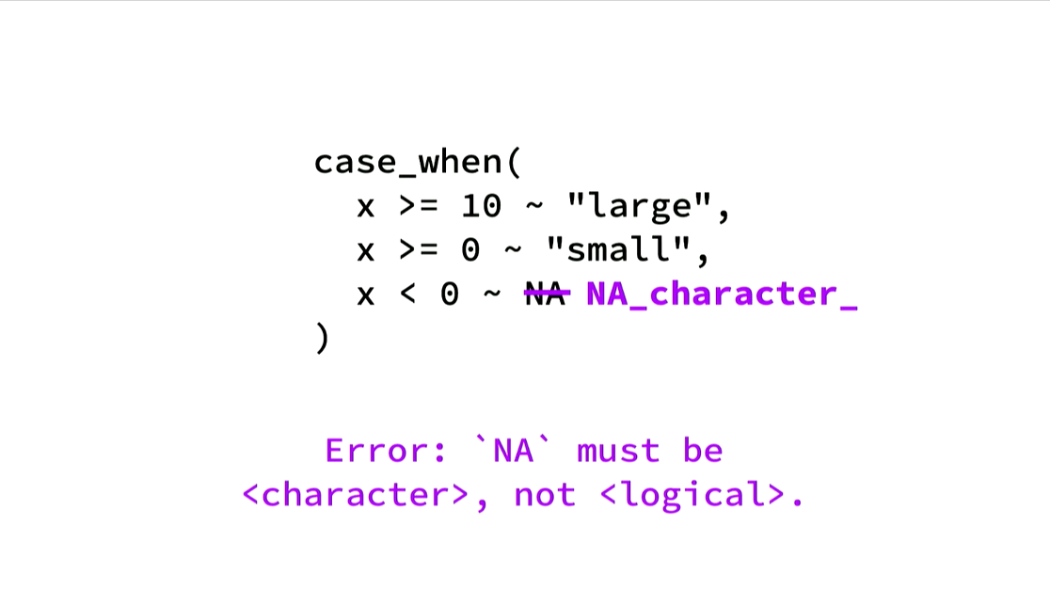
grouping
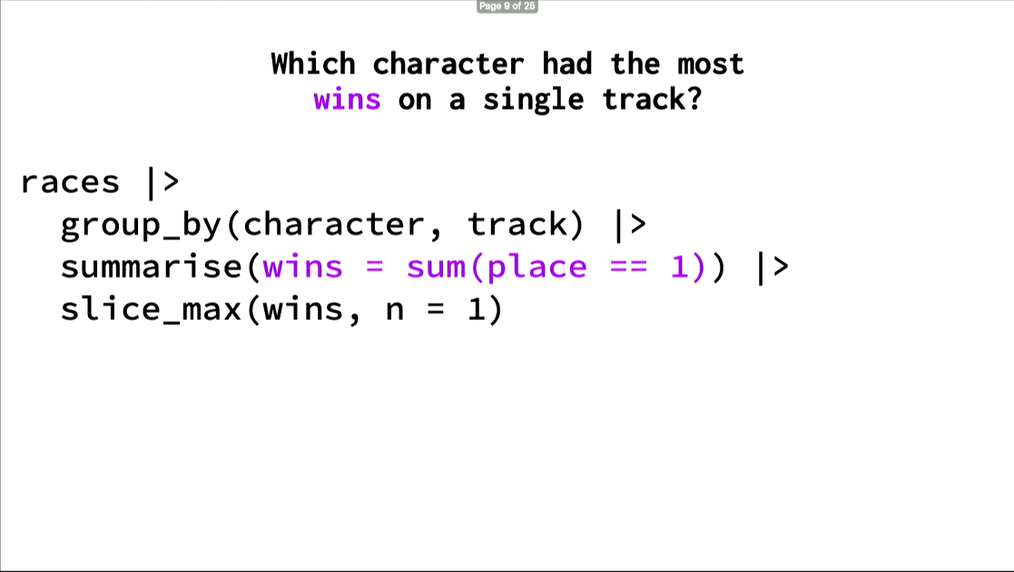
Bug:
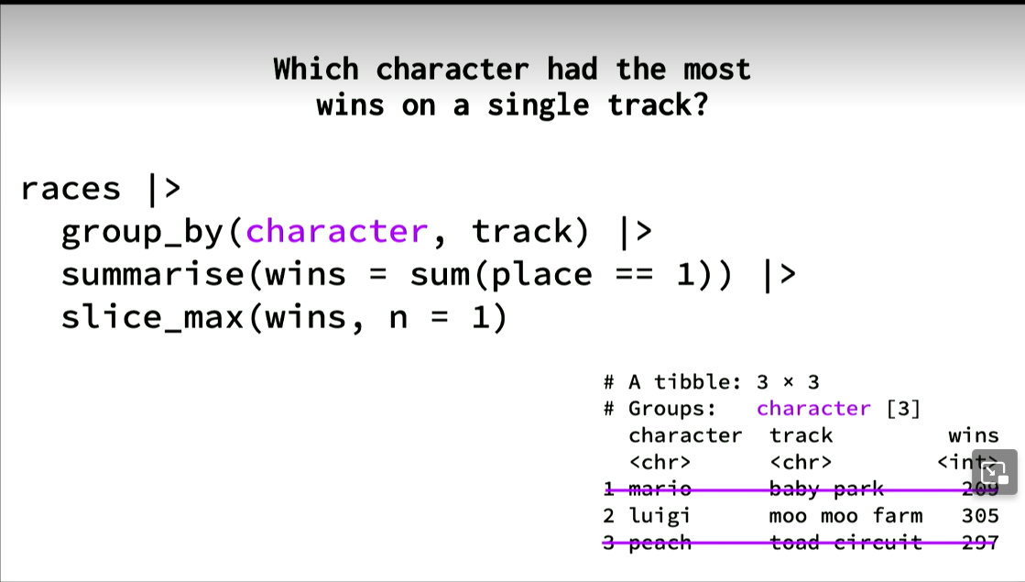
Because summarize takes off one layer, so you have to ungroup to do the correct result.
To solve this problem, in 1.1 you can write the grouping in line with the summarize call
rolling joints, overlap joints, 1 to 1 or 1 to many
question solved
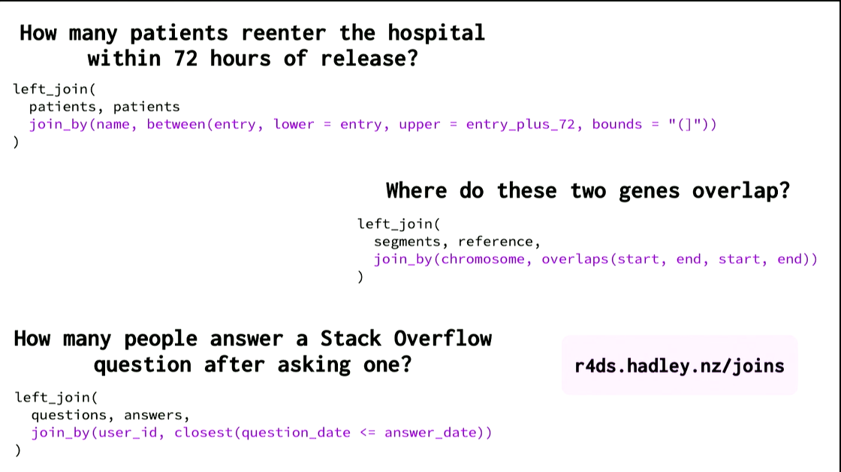
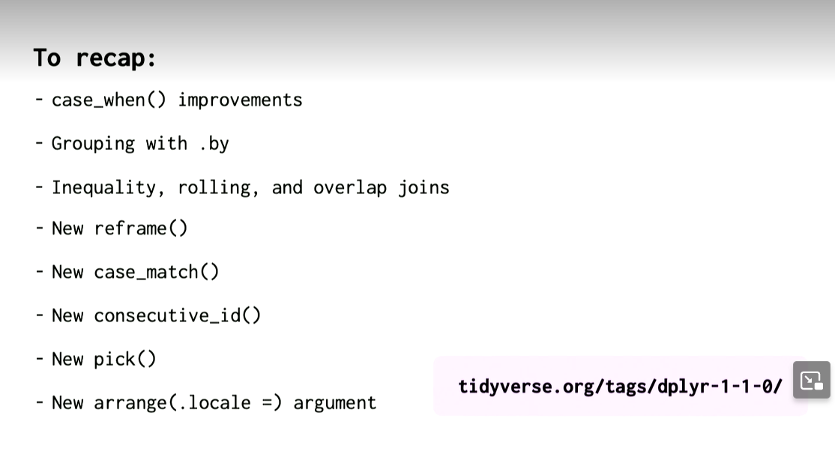
47 minuti -> shiny developers

